Column Family: Cassandra
- Create a keyspace called ‘weather_data’ with properties and write a query to select keypsace as ‘weather_data’.

create keyspace weather_data
with replication = {'class':'SimpleStrategy', 'replication_factor': 5};
use weather_data;

- Write a CQL query to verify and display keyspace.

describe keyspaces;

Output:
system_auth "OpsCenter" system_traces
system system_distributed weather_data

- Create a table called ‘weather’ with following properties such as city_id, city_name, city_cordinates (longitude, latitude), date, time, temperature, Humidity, Rainfall, Wind Speed, and Wind Direction.

create table weather(
city_id int primary key,
city_name text,
city_coordinates text,
cur_date date,
cur_time timestamp,
temperature int,
humidity int,
rainfall int,
windspeed float,
winddirection text);

- Write a CQL query to perform insertion of data into table “weather”.

insert into weather
(city_id,city_name,city_coordinates,cur_date,cur_time,temperature,humidity,rainfall,windspeed,winddirection)
values(1,'coimbatore','124,357',todate(now()),totimestamp(now()),32,19,45,19.2,'north');

insert into weather
(city_id,city_name,city_coordinates,cur_date,cur_time,temperature,humidity,rainfall,windspeed,winddirection)
values(2,'chennai','502,765',todate(now()),totimestamp(now()),38,21,56,13.2,'north_east');

insert into weather
(city_id,city_name,city_coordinates,cur_date,cur_time,temperature,humidity,rainfall,windspeed,winddirection)
values(3,'madurai','221,387',todate(now()),totimestamp(now()),34,16,40,12.2,'north');

- Write a CQL query to display all the data in the weather table.

select * from weather;

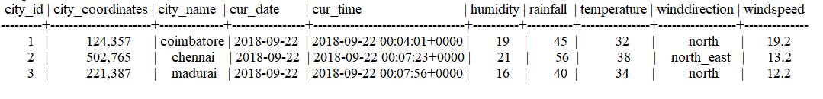

- Write a CQL query to update the temperature where city_name =”cbe”.

create index city_name on weather (city_name);
select * from weather
where city_name='coimbatore';

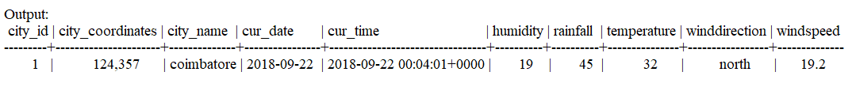

- Write a CQL query to delete the data where city_id=5.

delete from weather where city_id=3;

select * from weather;

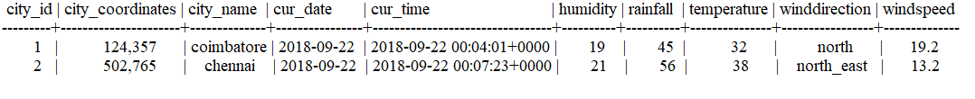

8. CQL Querying:
- Find the city which has maximum temperature in a day.
select city_name,max(temperature) from weather;

city_name | max(temperature)
-----------+--------------------
chennai 38

- Find the average rainfall for the particular city.
select avg(rainfall) from weather where city_name='coimbatore';

avg(rainfall)
--------------
50.6

